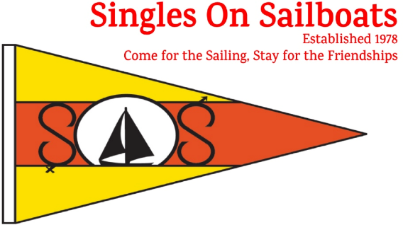
Exciting April Events
Spring Training
April 5, 2025
8:00 – 4:00
 | Location: | Anne Arundel community College, Arnold MD
 | Presentations: | Classroom settings covering a boatload of topics for all levels of experience. Click to see a Schedule of Classes
 | Cost: | $85 SOS Members on or before 3/22/25 (9pm)  $95 SOS Members after 3/22 (9pm)  $100 General Public and Walk-Ins
 | Register here: | Click
 | Registration Deadline: | March 30, 2025 (9pm)
Flare & Safety Day
April 19, 2025
9:00am – 11:00am
Hands on Training!
 | Location: | YMCA Camp Letts
 | Cost: | Free for all Members
 | Register here: | Click
 | Registration Deadline: | April 12, 2025 (9:00pm)
DOCKSIDE TRAINING
April 19, 20025
Great for New Members!
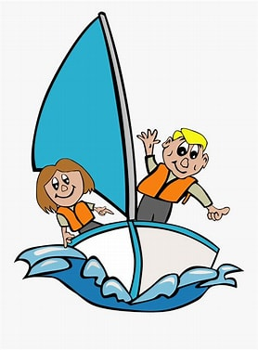 | Location: | Various Skippers’ Boats
 | Time: | Noon to 3:00 (following Flare & Safety)
 | Cost: | Free for all Members
 | Registration Deadline: | April 12, 2025 (9:00pm)
 | Note: | Bring your lunch and Basic Skills Check Sheets

All Members are welcome to participate in this hands-on training where they will have the opportunity to practice:
• Lighting Flares
• Firing a Flare Gun
• Using a Fire Extinguisher to extinguish a fire
• Techniques for safely using a winch
• Line Tossing
• Simulate Using a Passing Line
SOS Members Login To Register
Cost: FREE For All Member
Deadline: April 23, 2024 (9:00 PM)
See Whisker Pole article for more information.
SOS Wellness Policy
All participants attending SOS in-person events should be feeling well. They should not attend an event if they have symptoms of a communicable respiratory or gastrointestinal illness, are “feeling like something is coming on,” have a recent significant exposure to someone with a communicable respiratory or gastrointestinal illness, or have not waited a recommended isolation time after a recent respiratory or gastrointestinal infection.
In addition, a skipper/host may have further requirements or request other preventive measures (for example, crew or guests having received the currently recommended COVID-19 vaccine or wearing masks when below deck). All in-person participants should expect to be denied admission without a refund if they fail to comply with this policy.

Contact: info@singlesonsailboats.org (410) 798-4098
Flare & Safety Day
All Members are welcome to participate in this hands-on training where they will have the opportunity to practice:
• Lighting Flares
• Firing a Flare Gun
• Using a Fire Extinguisher to extinguish a fire
• Techniques for safely using a winch
• Line Tossing
• Simulate Using a Passing Line
Time: 9:00am - 11:00pm
Location: YMCA Camp Letts
To Register: Click
Cost: FREE For All Member
Deadline: April 12, 2025 (9:00 PM)
More information will be in the March edition of the Whisker Pole.
Old Fire Extinguishers Needed!
The club is always looking for old fire extinguishers to use at our annual Flare and Safety Day training. At that training, participants get the valuable experience of practicing the use of fire extinguishers to put out small fires.
If you have any that have expired, and you’re willing to donate them to this important cause, please reach out to Karl Scible by text at 407-707-2833.
SOS Wellness Policy
All participants attending SOS in-person events should be feeling well. They should not attend an event if they have symptoms of a communicable respiratory or gastrointestinal illness, are “feeling like something is coming on,” have a recent significant exposure to someone with a communicable respiratory or gastrointestinal illness, or have not waited a recommended isolation time after a recent respiratory or gastrointestinal infection.
In addition, a skipper/host may have further requirements or request other preventive measures (for example, crew or guests having received the currently recommended COVID-19 vaccine or wearing masks when below deck). All in-person participants should expect to be denied admission without a refund if they fail to comply with this policy.

